
International cities4youth Symposium
11 July 2025- Sakarya

Extended Abstract Title (14 Pt)

First Author*1, Second Author2 and Third Author3 (Full Name)

¹Institute, City, Country, e-mail, ORCID
²Institute, City, Country, e-mail, ORCID
³Institute, City, Country, e-mail, ORCID

ABSTRACT

The abstract should not be more than 200 words each. The abstract should not only indicate the subject and scope of the paper but also summarize the author’s conclusion. Structured abstract must be a brief, comprehensive summary of the contents of the article. It allows readers to survey the contents of an article quickly. An Abstract summarizes the major aspects of a paper. It should succinctly summarize the purpose of the paper, the methods used, the major results, and conclusions.

Key words: Keyword 1, Keyword 2, Keyword 3 (Min 3 key words & Max 5 Key words)

Introduction (Section Titles (Introduction, Main Results, Conclusion, etc.): Bold, with only the first letters capitalized.)

This format is to be used for submissions of extended abstract that will be published in the proceeding of the cities4youth. We wish to give this proceeding a consistent, high-quality appearance. We therefore ask that authors follow some simple guidelines. In essence, you should format your paper exactly like this document. The easiest way to do this is simply to download a template from the conference web site and replace the content with your own material.
In this section, author should address the following information which is Introduction and background of the research, Main Results and Conclusion. The extended abstract should be written in MS Word format in single-spaced in 11-point Times New Roman except for abstract (10-points Time New Roman). Do not indent the text paragraphs. Please briefly explain the aim and scope of the study, the materials and methods, and the main findings and brief analysis of the study. Please observe Figure 1 and Table 1 to include figures and tables in the abstract, respectively.

Authors are requested to submit the Extended Abstracts (maximum of 4 pages in the length including the references and pages should be numbered.) in electronic form (MS-Word) via our Online Submission. The incorrect formats may result in your

abstract being returned to you by e-mail. The scientific committee will select the contributions for oral and poster presentations.

A digital version of the cities4youth Proceeding will be published in the conference website.

Main Results

In this section, author should address the following information which is finding and discussion. Figures can be included in your extended abstract and referred to in the text. Please ensure that the figures are inserted in the text box provided below.

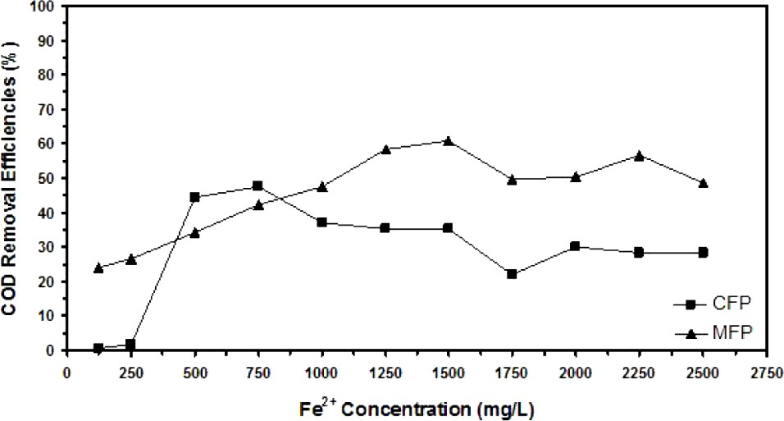
Figure 1. Example of figure for the full paper.

A table should be inserted like the one below and referred in the text. Please avoid vertical rules and shading in table cells.

Table 1. Example of table for the extended abstract

Contents of Table

A maximum of 1 table and 1 figure is allowed.

Conclusion

The conclusion is intended to help the reader understand why your research should matter to them after they have finished reading the paper. A conclusion is not merely a summary of the main topics covered or a re-statement of your research problem but a synthesis of key points and, if applicable, where you recommend new areas for future research.

Acknowledgment: The authors would like to express their appreciation for the support of

the sponsors with Project No xxxx.

REFERENCES (Numbered, Vancouver Style)

- Author. Title. Journal. Year; Volume (Issue): Pages. (Journal Article)
- Author. Title. Conference Name; Date; Conference Location. Place Published: Publisher; Year Published. (Conference Papers)
- Author. Title. Conference Name; Year of Conference Date; Conference Location. Place Published: Publisher; Year Published. (Conference Proceedings)
- Schwartz, M. Title. Edition. Series editors. Place Published: Publisher; Year Date. Number of Pages.
(Book)
- Author. Title. In: Editor’name, editor. Book Title. Series Title. Volume. Edition. Place Published: Publisher, Year. Pages. (Book Section)
- Author. Title [Thesis Type]. Place Published: University; Year. (Thesis)

